Design and Implementation of a Secure Phone-as-Car-Key Platform for Car Rental Services

Shane Power - 20102592

Contents
Introduction 4
Functional Summary 5
Assumptions 6
Functional Requirements 7
System Context 7
Detailed Requirements 7
1. Car Key App 7
2. Vehicle Access Control Unit (VACU) 8
3. CANoe and Vehicle Network 9
4. Cloud Backend and Manager App 9
Data Requirements 10
System Design Diagrams 12
Functional Decompositions 12
Car Key App 12
Vehicle Access Control Unit 13
CANoe 13
Cloud Backend and Manager App 14
Sequence Diagrams 14
Successful Unlock/Lock 14
Unlock Failed (Key Invalid) 15
Manager Revoking Key 16
Methodology 17
V-Model overview 17
Android App V-model implementation 17
1. Phase 1: Requirements Analysis 17
1.1 Functional Requirements 17
1.2 Non-Functional Requirements 18
1.1 Data Requirements and Data Models 18
1. Phase 2: System Design 20
1.1 Architecture Decision 20
1.2 Navigation Flow 20
1.3 System Test Scenarios 21
2. Phase 3: Module Design 21
2.1 Security Manager 21
2.2 BleManager 21
2.3 HomeViewModel BLE integration 22
2.4 Test Design 22
3. Phase 4: Development 22
3.1 Android Keystore Integration 22
3.2 Tamper and Replay Protection 23
3.3 Test Coverage 23

Introduction
This project aims to design and implement a secure smartphone-based digital car key system, with a focus on car rental and car fleet management. The aim of the system is to replace traditional physical keys with securely provisioned digital keys. This will improve user convenience and reduce the administrative overhead and the security risks associated with handling physical keys. This is inspired by the shift in the car industry towards keyless vehicle access, and the growth of contactless, app-based car rental services.
The proposed prototype consists of a mobile Car Key App, a Vehicle Access Control Unit (VACU) running on a PC with Python, a cloud based management platform with an application for fleet managers, and a CAN interface using Vector CANoe. The Car Key App authenticates the user using biometric or PIN verification and initiates a secure unlock request. This request is transmitted via Bluetooth Low Energy (BLE) to the VACU, which performs access validation and cybersecurity checks like a vehicle lock ECU.
When the VACU receives a lock/unlock request, it validates it by checking its encryption key against stored keys in the cloud database and uses cybersecurity techniques such as checking the timestamp and cryptographic nonce. When access is approved, the VACU forwards the request to CANoe through a COM interface, which generates and transmits a real Controller Area Network (CAN) message to a Jaguar Land Rover vehicle testing rig. This message is used to wake the rig and simulate vehicle access behaviour, such as door lock and unlock events, showing interaction with real vehicle equipment.
The cloud backend provides fleet management functionality through a Manager App. This includes secure user authentication, digital key provisioning and revocation, temporary guest access management, and event logging. Fleet managers can remotely assign vehicles, monitor access activity, and revoke digital keys, allowing them to manage their fleet through a single app.
A comprehensive threat model will be developed to analyse potential cybersecurity risks in the system, such as replay attacks, relay attacks, and device compromise. These threats will be evaluated through controlled testing, and techniques to protect against these demonstrated such as authentication, nonces, timestamps, and secure communication channels between the system components. This will evaluate the security, practicality, and realism of a digital car key system from a cybersecurity point of view.

Functional Summary
This project will develop a secure smartphone based digital car key system, aimed at improving user experience and fleet management for car rental services. The system replaces physical keys with a digital authentication and unlock process through a mobile app, which provides improved security and convenience for customers and fleet companies.
The Car Key App is the user’s interface for authentication and vehicle access. Users unlock the app using biometrics(Face ID, fingerprint) or PIN and can then initiate an unlock or lock request. The app validates the user’s session and encryption key against data from the cloud backend.
Once the request is validated, the app sends an unlock command to the Vehicle Access Control Unit (VACU) running on a PC, via Bluetooth Low Energy (BLE). The VACU processes the unlock request and enforces defined cybersecurity and authorisation rules, such as cryptographic key pair checking, digital certificates, timestamp and nonce checking, similar to a real vehicle ECU. Rather than directly controlling the vehicle hardware, the VACU acts as the secure control point between the mobile app and the vehicle test environment.
Upon authorisation, the VACU forwards the request to CANoe, which is responsible for generating and transmitting a real Controller Area Network (CAN) message to the Jaguar Land Rover testing rig. This CAN message is used to wake the rig and trigger simulated vehicle access behaviour, such as door lock or unlock events.
The cloud backend manages user authentication, digital key provisioning, and event logging. Through the Manager App, fleet operators can create, assign, and revoke digital keys, manage temporary guest access, and monitor vehicle access activity. The cloud service supports scalable fleet operation and implements key revocation in the case of a lost or stolen device, as well as real-time updates of any access requests.
Overall, the system integrates mobile biometric authentication, Bluetooth Low Energy communication, CAN based vehicle communication, and cloud based fleet management to demonstrate a secure, contactless car key solution for modern rental and fleet use cases.

Assumptions
- The smartphone used for testing supports Bluetooth Low Energy (BLE) and can hold a stable BLE connection with the Vehicle Access Control Unit (VACU).
- The Jaguar Land Rover (JLR) testing rig is available and operational, allowing CANoe to transmit real Controller Area Network (CAN) messages to wake the rig and trigger simulated vehicle functions such as door lock and unlock behaviour.
- The cloud backend is available and provides reliable services for user authentication, digital key provisioning, and event logging throughout the testing period.
- The Car Key App and the Manager App need to have access to a stable internet connection to communicate with the cloud backend.
- The user’s device should be able to implement secure key storage through the Android Keystore or an equivalent built-in security system.
- All digital certificates and cryptographic key pairs required for authentication and secure communication can be generated securely and stored appropriately
- The Vehicle Access Control Unit (VACU) is running on a system that supports BLE communication and has enough processing power to process and send unlock requests in a reasonable timeframe
- Cloud service latency remains within acceptable limits to support near real time event logging and fleet management updates.
- The prototype will be evaluated within a controlled hardware and network environment, and doesn’t account for large-scale deployment or any hostile network conditions beyond those considered in the threat model.

Functional Requirements

System Context

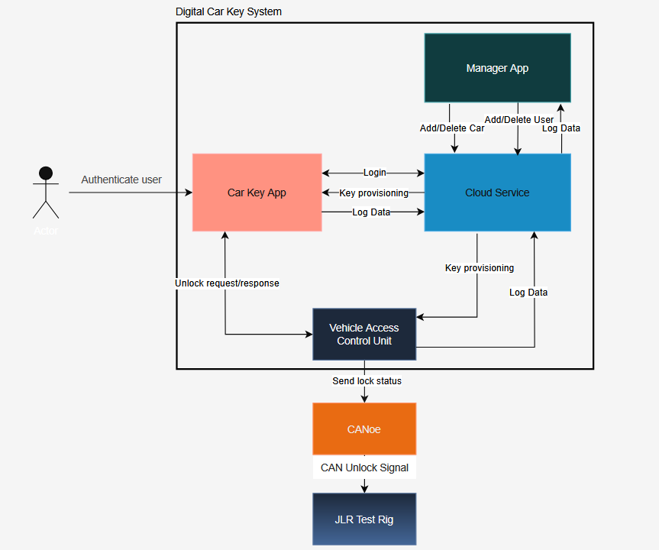

Detailed Requirements

Car Key App

  - User Authentication
    - The mobile app must allow users to authenticate using biometrics (fingerprint, Face ID) or a secure PIN.
    - Only authenticated users can access key management or vehicle unlock functions.
    - Authentication tokens must be stored securely within the phone’s keystore.

  - Key Provisioning and Management
    - The app must synchronise with the cloud backend to validate key status, permissions, and user roles before issuing unlock commands.
    - The app must handle temporary guest keys with time-limited access or restricted permissions.
    - The app must reject commands if the key is revoked or expired.

  - Secure Communication and Unlock Process
    - The app must communicate with the BLE–CANoe interface via Bluetooth Low Energy (BLE).
    - Unlock commands must be bound to an authenticated user session and a valid KeyID.
    - The app must provide clear feedback to the user for command success, failure, or connection errors.

  - Data Handling
    - Private keys for each digital key must be stored in the phone keystore.
    - KeyID attributes include: KeyID, VehicleID, UserID, Expiry Date/Time, Permissions, Key status (active or revoked).
    - Unlock events generated by the app must be logged to the cloud with timestamp, user ID, vehicle ID, and action.

Vehicle Access Control Unit (VACU)

  - Communication Role
    - The VACU must establish and maintain BLE connections with authorised mobile
devices.
    - The VACU must receive unlock and lock commands from the Car Key App in a
reliable and timely manner.
    - The VACU must handle BLE disconnections and reconnections properly without system failure.
2.2 Access Control and Cybersecurity
2.2.1. The VACU must validate any incoming commands against the defined security and authorisation rules before forwarding the command to CANoe.
2.2.2. Commands must be rejected if the required validation checks fail.
2.2.3. The VACU must act as the only access point between the mobile application and the vehicle network.
2.3 Integration with CANoe
2.3.1. Upon successful validation, the VACU must forward authorised commands to CANoe.
2.3.2. The VACU must not directly generate or transmit CAN messages onto the vehicle network.
2.3.3. Communication between the VACU and CANoe must be reliable and have minimal latency.

CANoe and Vehicle Network

  - CAN Message Generation
3.1.1 CANoe must generate valid CAN messages corresponding to actions on the test rig such as ignition status, door lock status.
3.1.2 CAN messages must conform to the expected format of the JLR testing rig.
3.1.3 CANoe must transmit messages reliably onto the CAN bus.
3.2 Test Rig Interaction
3.2.1 CANoe must be capable of waking the Jaguar Land Rover testing rig using CAN signals.
3.2.2 Simulated vehicle behaviour, such as door lock and unlock events, must be triggered by the CAN messages.
3.3.3 Monitoring of CAN messages sent and received to the test rig should be possible through CANoe.

Cloud Backend and Manager App

  - User and Key Management
4.1.1 The cloud backend must manage all user authentication and role-based access control.
4.1.2 Fleet managers must be able to create, assign and revoke digital keys through the Manager App.
4.1.3 Changes to key status must be synchronised across the system in quick time.
4.2 Event Logging and Requirements
4.2.1 All unlock and lock attempts must be logged, including successful and failed actions.
4.2.2 Log entries must include timestamp, user ID, vehicle ID, action performed, and the result.
4.2.3 Fleet managers must be able to view access logs through the Manager App.
4.3 Security and Data Protection
4.3.1 Communication between components in the system and the cloud backend must use encrypted channels.
4.3.2 Sensitive data stored in the cloud must be protected using encryption and access controls.
4.3.3 Key revocation should be possible, in the case of a stolen or lost phone, or compromise of the vehicle.

Data Requirements

- User Data
  - Each user will have a unique User ID which will be managed by cloud authentication.
  - User profiles will include basic details such as name, email, and the assigned role (driver, manager)
  - Authentication data such as passwords or biometrics will be securely stored and encrypted by secure cloud storage and the keystore on device.

- Digital Key Data
  - Each key will be represented by a KeyID which will be linked to a specific vehicle and user.
  - The private key associated with each digital key will be stored on the phone keystore only.
  - Attributes for KeyID include:
    - KeyID
    - VehicleID
    - UserID
    - Expiry Date and Time
    - Permissions
    - Public key associated with Vehicle Access Control Unit (VACU)
    - Key status (active or revoked)

- Vehicle Data
  - Each vehicle entry in the database will have:
    - VehicleID
    - Vehicle Type / Model
    - Associated Vehicle Access Control Unit
    - Current Status
    - Assigned User

- Unlock Event Log
  - Every unlock attempt will be logged to the cloud
  - Each log entry includes
    - LogID
    - Timestamp
    - UserID
    - VehicleID
    - Action ( Unlock or Lock)
    - Result (Success or Failure)
    - Nonce

- Vehicle Access Control Unit Data
  - The VACU will store:
    - Unique VACU Identifier
    - Public keys of valid users
    - Latest valid nonces and timestamps for replay attack prevention
    - Log data

- CAN Bus data
  - CAN bus will send CAN messages to JLR rig to request unlock/lock

- Data Security
  - All data transmitted between system components must be encrypted using secure communication protocols.
  - Secure cloud storage will handle secured storage of user, vehicle and event data
  - Keys and credentials will be stored using phone keystore and secure cloud storage.

System Design Diagrams

Functional Decompositions

Car Key App
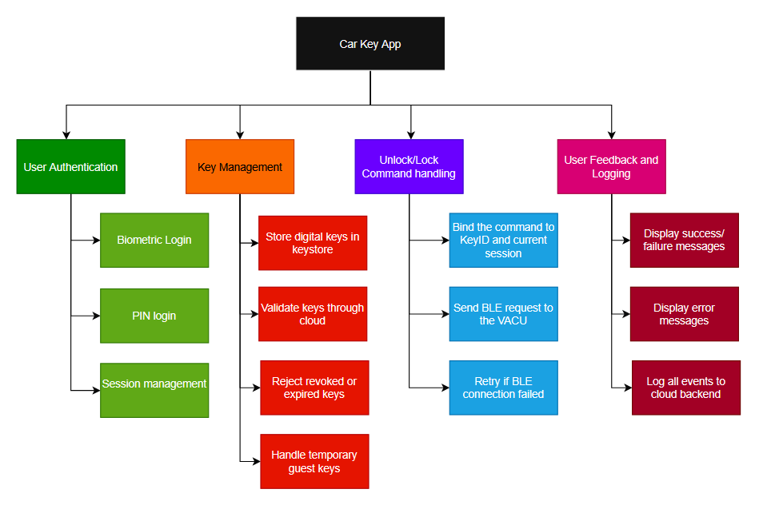

Vehicle Access Control Unit
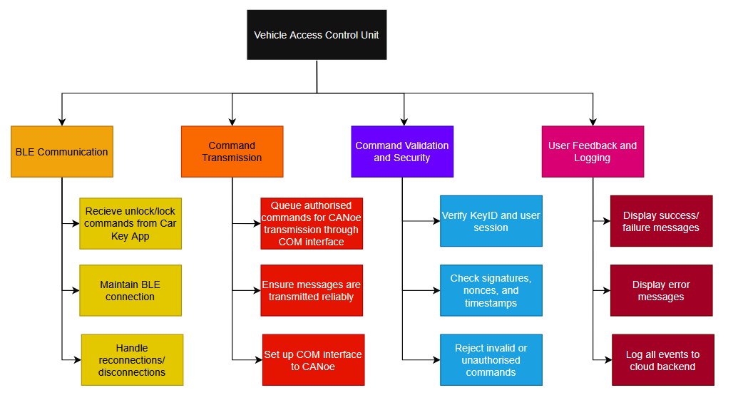

CANoe
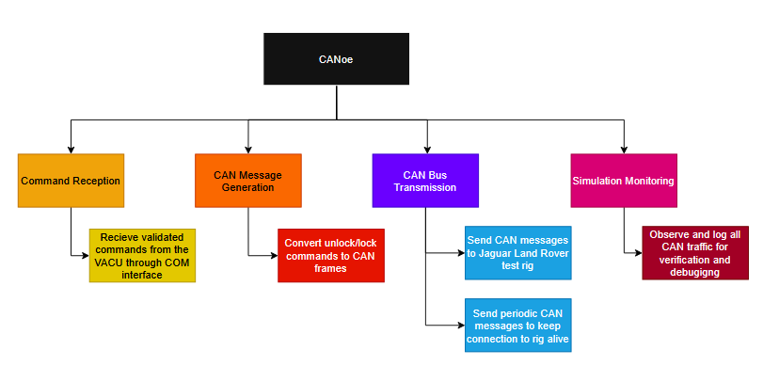

Cloud Backend and Manager App
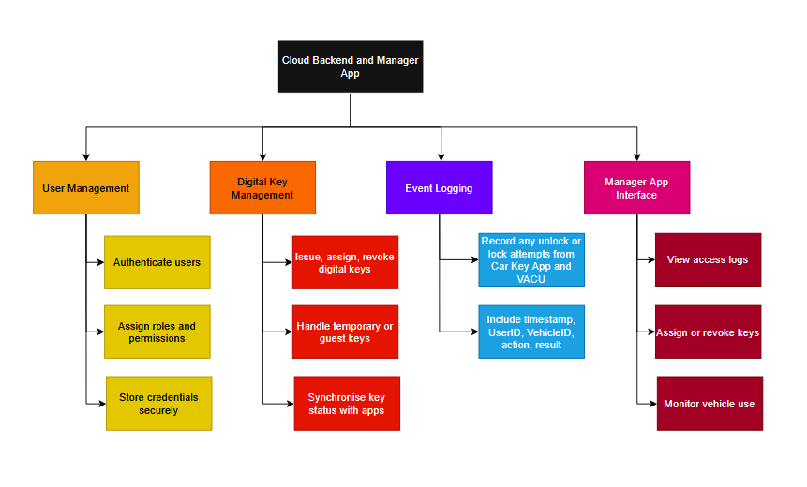

Sequence Diagrams

Successful Unlock/Lock
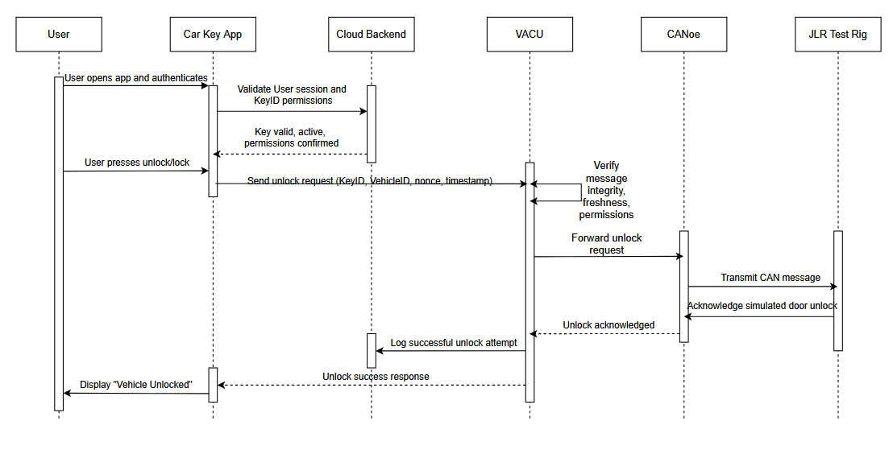

Unlock Failed (Key Invalid)
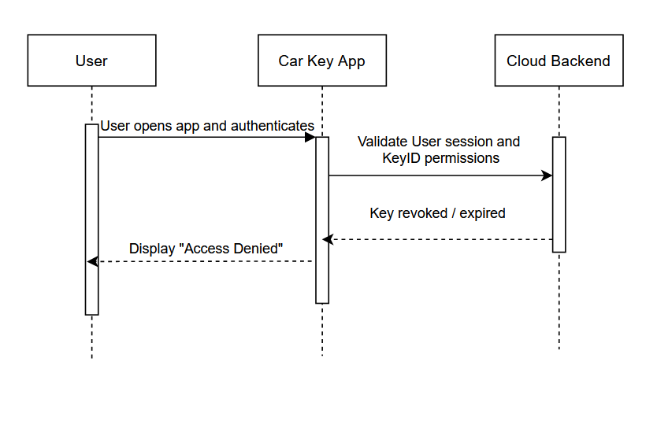

Manager Revoking Key

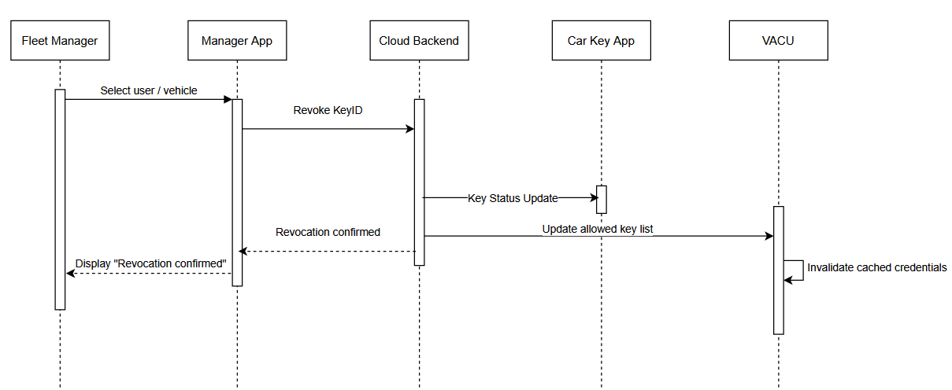

Methodology
The V-Model was selected because it is the industry standard for safety-critical and automotive software - each development phase has a directly corresponding test phase, ensuring all requirements are verifiable and traceable throughout the project.

V-Model overview
The V-Model structures development as a descending left arm (design/specification) and an ascending right arm (verification/testing), meeting at implementation at the bottom:
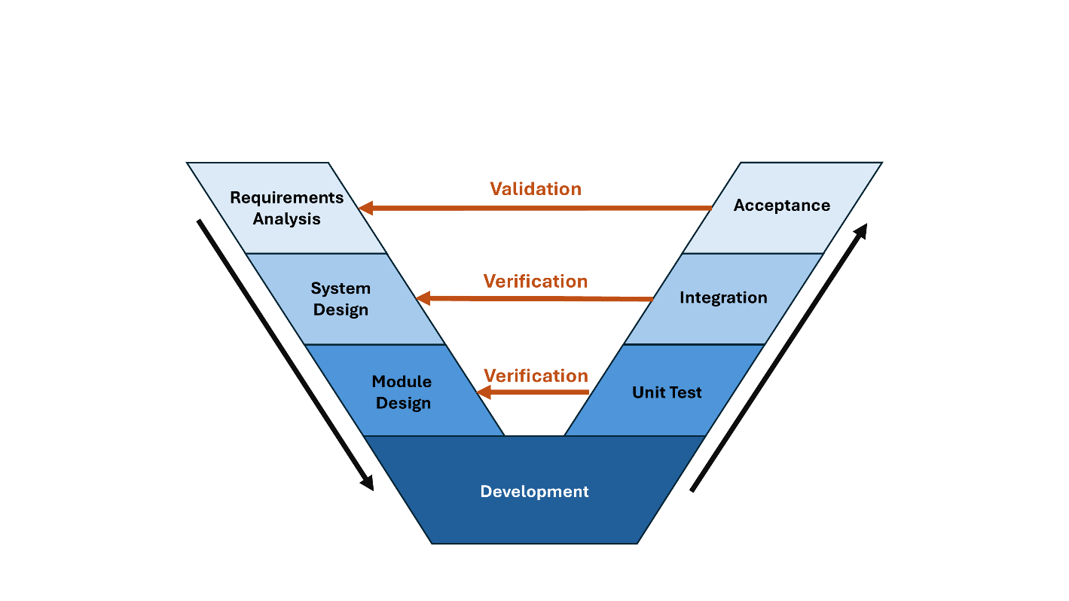

Android App V-model implementation

Phase 1: Requirements Analysis
This phase directly corresponds with the Acceptance test phase. The goal of this phase is to define what the system must do, what data it must manage, and what the acceptance criteria are.

Functional Requirements
ID | Requirement
FR-01 | The app shall allow a registered user to log in using their email address and password via Firebase Authentication.
FR-02 | The app shall display the vehicle and digital key assigned to the logged-in user, retrieved from Cloud Firestore.
FR-03 | The app shall allow a user with an active digital key to send a lock command to the VACU over Bluetooth Low Energy.
FR-04 | The app shall allow a user with an active digital key to send an unlock command to the VACU over Bluetooth Low Energy.
FR-05 | The app shall prevent lock/unlock actions if the user's digital key has expired or been revoked.
FR-06 | The app shall include a nonce and timestamp in every BLE command to prevent replay attacks.
FR-07 | The app shall log every lock/unlock event (timestamp, userId, vehicleId, action, result, nonce) to Cloud Firestore.
FR-08 | The app shall allow the user to log out, clearing the active session.
FR-09 | The app shall display the current BLE connection status to the user.
FR-10 | The app shall support temporary guest keys with an expiry date.

Non-Functional Requirements
ID | Requirement
NFR-01 | The app shall allow a registered user to log in using their email address and password via Firebase Authentication.
NFR-02 | The app shall display the vehicle and digital key assigned to the logged-in user, retrieved from Cloud Firestore.
NFR-03 | The app shall allow a user with an active digital key to send a lock command to the VACU over Bluetooth Low Energy.
NFR-04 | The app shall allow a user with an active digital key to send an unlock command to the VACU over Bluetooth Low Energy.
NFR-05 | The app shall prevent lock/unlock actions if the user's digital key has expired or been revoked.
NFR-06 | The app shall include a nonce and timestamp in every BLE command to prevent replay attacks.
NFR-07 | The app shall log every lock/unlock event (timestamp, userId, vehicleId, action, result, nonce) to Cloud Firestore.
NFR-08 | The app shall allow the user to log out, clearing the active session.

Data Requirements and Data Models
The following data models were defined based on the functional requirements. These are implemented as Kotlin data classes and correspond directly to Firestore collections.

1.3.1 User
Represents a registered user of the system. Stored in the users Firestore collection.
data class User(
val userId: String = "",
val name: String = "",
val email: String = "",
val role: UserRole = UserRole.DRIVER
)
enum class UserRole {
DRIVER, // Can only lock/unlock their assigned vehicle
MANAGER // Can provision, assign and revoke keys
}

1.3.2 DigitalKey
Represents a provisioned digital key linking a user to a vehicle. Stored in the digitalKeys Firestore collection.
data class DigitalKey(
val keyId: String = "",
val vehicleId: String = "",
val userId: String = "",
val status: KeyStatus = KeyStatus.ACTIVE,
val expiryDate: com.google.firebase.Timestamp? = null,
val permissions: List<String> = emptyList()
)
enum class KeyStatus {
ACTIVE, // Key is valid and can be used
REVOKED, // Key was explicitly revoked by a manager
EXPIRED // Key passed its expiry date
}

1.3.3 Vehicle
Represents a vehicle in the fleet. Stored in the vehicles Firestore collection.
3.3.4 data class Vehicle(
val vehicleId: String = "",
val make: String = "",
val model: String = "",
val registrationPlate: String = "",
val currentKeyId: String? = null
)

1.3.4 VehicleEvent
Represents a logged lock or unlock event. Stored in the vehicleEvents Firestore collection. Every lock/unlock attempt is logged here for auditability.
data class VehicleEvent(
val logId: String = "",
val timestamp: com.google.firebase.Timestamp? = null,
val userId: String = "",
val vehicleId: String = "",
val action: VehicleAction = VehicleAction.UNLOCK,
val result: EventResult = EventResult.SUCCESS,
val nonce: String = ""
)
enum class VehicleAction { UNLOCK, LOCK }
enum class EventResult { SUCCESS, FAILURE }

Phase 2: System Design
This phase directly corresponds with the Integration test phase.

Architecture Decision
Adopted the MVVM (Model-View-ViewModel) architectural pattern, which separates the UI logic (View) from business logic (ViewModel) and data (Model). This approach improves testability as Views and ViewModels can be tested in isolation. It also impoves maintainability as code is more organised and easier to understand. The MVVM was implemented with the following layers:
Layer | Package | Responsibility
Data models | data/ | Data classes that match Firestore schema
Auth | data/login/ | Firebase Auth via AuthManager
Firestore stores | data/firestore/ | One object per collection (KeyStore, VehicleStore, EventStore)
Repository | data/repository/ | Single FirebaseRepository coordinating the stores
Service | service/ | BleManager,Bluetooth logic implemented in phase 3
Viewmodels | ui/viewmodels/ | AuthViewModel, HomeViewModel
Screens | ui/screens/ | Composable screens
Components | ui/components/ | Reusable Components for screens
Navigation | ui/navigation | AppDestinations, AppNavGraph
General UI | ui/general/ | TopAppBarProvider, AppNavDrawer

Navigation Flow
There are two destinations defined in AppDestinations.kt. Login (route: "login") and Home (route: "home"). Login is the startDestination. On successful login, the Login route is popped from the back stack so the user cannot navigate back to it.
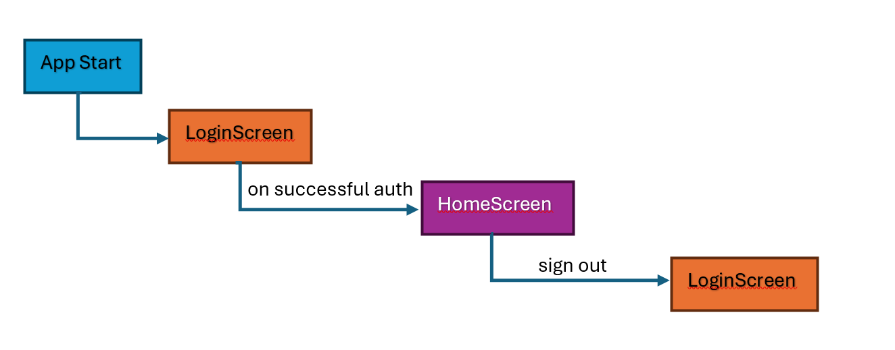

System Test Scenarios

ID | Scenario | Expected Result
ST-01 | Launch app with no active session | LoginScreen is shown, HomeScreen is not accessible
ST-02 | Login with valid Firebase credentials | Navigates to HomeScreen, Login removed from back stack
ST-03 | Press back from HomeScreen after login | App exits, does not return to Login Screen
ST-04 | Sign out from drawer | Returns to LoginScreen, clear session
ST-05 | Launch app with existing active session | Goes directly to HomeScreen (auto-login)
ST-06 | HomeScreen loads with active key | Vehicle name, reg and "Key Active" status displayed from Firestore
ST-07 | HomeScreen loads with revoked key | Lock/Unlock buttons disabled, "Key Revoked" shown

Phase 3: Module Design

This phase focuses on breaking down the system architecture into individual modules. In this phase, each module’s behaviour and responsibilities are defined along with the interfaces between them. This phase corresponds with the unit testing phase.

Security Manager

This module constructs and parses the BLE payloads with the correct format. The payload has the format [command] : [nonce] : [timestamp]. The nonce is a 32 character randomly generated hex string, and the timestamp uses the Unix millisecond value. This format of message adheres to functional requirement FR-06 which aims to prevent replay attacks by using a unique nonce and timestamp.

BleManager

This module implements the Bluetooth Low Energy GATT functionality. The app advertises a custom service with a unique UUID. The app then accepts incoming connections from the VACU, which functions as the GATT central. The app notifies the VACU upon connection using a GATT characteristic. The BleManager module only starts once the user grants Bluetooth permissions for the app.

HomeViewModel BLE integration

The HomeViewModel was updated to integrate BLE status into the UI viewmodel, checking on unlock/lock for an active BLE connection and showing an error on the UI if commands are sent without being connected to the VACU.

Test Design
Unit tests were created for SecurityManager to check the payload structure, nonce generation and checks validity of payload throughout parsing process. Integration tests were created for BleManager to verify the Bluetooth service initialises correctly and starts as disabled.

Phase 4: Development

The development phase focused on completing the CarKey system, implementing cryptographic signing for unlock/lock commands, stored on hardware using Android Keystore.

Android Keystore Integration

Cryptographic signing of messages was implemented into the SecurityManager. Every BLE payload is signed using HMAC-SHA256, a widely used cryptographic standard. When the app is first used, the signing key is generated and stored in Android Keystore. This is a secure key enclave available on modern Android versions that stores the key directly in hardware, making it difficult to capture for an attacker. The payload format was extended to four fields:

[command] : [nonce] : [timestamp] : [hmac-signature]

The signature is generated using the first three fields. The parsePayload function verifies the signature before returning any messages. If the payload has an invalid command, bad nonce or invalid signature it is rejected and nothing is returned.

Tamper and Replay Protection

The use of signatures now prevents two forms of attack:
Replay Attack: each nonce is unique, so a previously generated payload can’t be resent to trigger an action again.
Payload tampering: changing any part of the payload will invalidate the signature

Test Coverage

Unit tests were created covering nonce generation and parsePayload payload rejection functionality. Tests for key signing, tamper detection, and payload verification are covered in SecurityManagerInstrumentedTest.

Implementation

Security Implementation

Cybersecurity Goals

- Secure Authentication
  - Ensure that only authorised users can unlock vehicles.
  - Authentication should be implemented through biometrics or secure PIN.
  - In the case of a phone being stolen or lost, unauthorised use should be prevented through key revocation.
- Data Confidentiality
  - All sensitive information (nonces, KeyIds, cryptographic keys) should be protected while in transit and at rest.
  - Any Bluetooth Low Energy communication should be protected by ensuring BLE Secure Connections are used, by implementing pairing and bonding.
  - Communications between the Car Key App, VACU and the Cloud Backend should be protected with TLS.
- Data Integrity
  - It should be ensured all unlock requests are unaltered and genuine.
  - Replay attacks should be prevented by implementing challenge response techniques, such as nonces, signatures, and timestamps.
  - The VACU should validate every request before sending any signals to the vehicle network.
- Data Availability
  - In the case of a network failure, the system should handle the failure gracefully and return to a safe resting state.
  - To avoid brute-forcing attacks, a time lockout should be implemented between each unlock attempt.
- Accountability
  - There should be a secure and complete log of all unlock or lock events.
  - The logs should include the timestamp, UserID, VehicleID, the action, the result, and nonce.

Threat Model

Potential Threat Sources:
- External Attacker: An attacker trying to access a vehicle without a valid key
- Insider Threat: A manager with privileges, abusing their authority
- Man In the Middle: An attacker intercepting Bluetooth or cloud communication
- Replay Attacker: An attacker who captures a successful unlock command and replays it to trigger an unlock.
- Compromised Device: A connected phone or PC that has been tampered with

Potential Attack Types:
- Unauthorised Access from External Attacker
In this attack, the attacker has obtained a KeyID or valid credentials from a phone or the cloud. This would allow the attacker to unlock a vehicle.
To mitigate this:
- Biometric and PIN authentication implemented
- Keys are stored securely in the phone’s keystore
- Key revocation ensures compromised keys are deactivated

- Replay Attack
In this attack, the attacker captures a valid unlock message sent through BLE from a user’s phone to the VACU. The attacker can then transmit this unlock message to the VACU again to trigger a successful unlock.
To mitigate this:
- Nonces are implemented for each unlock request. A nonce is short for “number once” and is a randomly generated number that is used only once in a communication. The nonce includes a timestamp which guarantees the message is only valid for a specific period.
- A challenge-response protocol is implemented, where the VACU will send a challenge to the phone app consisting of the nonce, timestamp and its identifier. The phone app will sign this challenge with the private key stored in the phone’s keystore and send it back to the VACU. The VACU will check the nonce and timestamp to ensure the unlock request wasn’t sent before.

- Man In the Middle Attack
In this attack, an attacker intercepts the BLE transmission between the phone and the VACU and can pretend to be the phone to the VACU, or pretend to be the VACU to the phone. The attacker can then try to replay old unlock requests or inject their own unlock requests into the transmission. To mitigate this:
- Nonce and timestamp implementation prevent replay attacks
- Only the phone itself has the private key in its keystore to sign the challenge response. If an attacker tries to change the message, the VACU will refuse to verify the signature.
- BLE Secure Connection will be implemented, which use pairing and bonding to encrypt communication from device to device.

- Cloud Data Breach
In this attack, the cloud backend is compromised. Private user data could be access, and access to key provisioning options could be accessed by an attacker, allowing unauthorised devices to be allocated keys. To mitigate this:
- Private keys are stored on user’s phones, so an attacker still needs to gain access to a user’s phone to issue unlock requests.
- TLS Encryption is implemented
The mitigation of these threats will be demonstrated and each attack vector will be tested in a controlled environment, to show the system’s resilience against cybersecurity attack.

Testing

Results

Reflection

Conclusion

